Summary:

Pg1 – NMDS with all sample types in separate

Pg2 – NMDS of bacteria and fungi without N or only-frass samples (has permanova stats on https://github.com/PedroBeschoren/shaphan_ECA/blob/main/Results/Permanova_output.txt)

Pg3 - heattree_Bac_pannel heattree_Bac_pannel. Taxonomies of ASVs that were different in pairwise comaprsions between treatments. Used as a follow-up of the permanovas, and describes some of the main differences between groups

Ps4: heattree_Fun_pannel : same as above, but for fungi

Ps5: heattree_Bac_source_on_CompostedUncomposted . separate composed and uncomposted samples, then look at the source effects one ach of them

Pg6: heattree_BacFun_Dose_025 : compares dose 0 to 2 and 5. More meaningful for bacteria than fungi, absed on the output in page1

Pg6 heattree_BacFun_source_NXY: compares source N to X and Y. More meaningful for Fungi than bacteria, absed on the output in page1

Pg7 Alpha diversity plots and testsNMDS_**Bac**_3_sample_types:

The results indicate a distinct separation of the NoFrass control from the frass amendments, with the frass dose being the major contributing factor to this differentiation. The observed differentiation is particularly evident in the rhizosphere samples (Fig. 1A and B).

In frass samples (Fig. 1C), it is evident that composting significantly increases the similarity of microbial communities. However, noticeable differences between sources X and Y are still discernible.

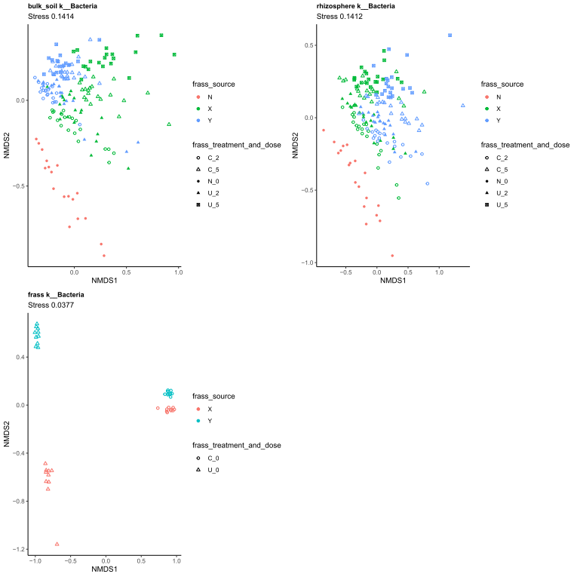

**Fig. 1** Non-metric multidimensional scaling (NMDS) plot of the beta diversity of **bacterial** communities in the rhizosphere, bulk soil and frass data based on bray-Curtis' distances. The stress values are used as a measure of how well the plot represents the dissimilarity or distance between the data points. The stress value ranges from 0 to 1, where lower values indicate a better fit or representation of the original dissimilarity matrix. A stress value close to 0 suggests a highly accurate representation of the data, meaning that the distances between points in the NMDS plot closely match the original dissimilarities. On the other hand, a stress value closer to 1 indicates a poorer fit, suggesting that the NMDS plot does not accurately reflect the dissimilarity structure of the data.

NMDS_**Fun**_3_sample_types:

The results demonstrate a distinct separation between the NoFrass condition and all other conditions, with the frass source being the primary factor contributing to this differentiation (Fig. 2A and B). This distinction is particularly pronounced in the rhizosphere samples (Fig. 2B).

Regarding frass samples, notable differences are observed between composted and uncomposted frass, although such differences are not apparent when comparing the different frass sources. It is worth noting that the differentiation among the microbial communities is less pronounced compared to the bacterial communities (Fig. 2C).

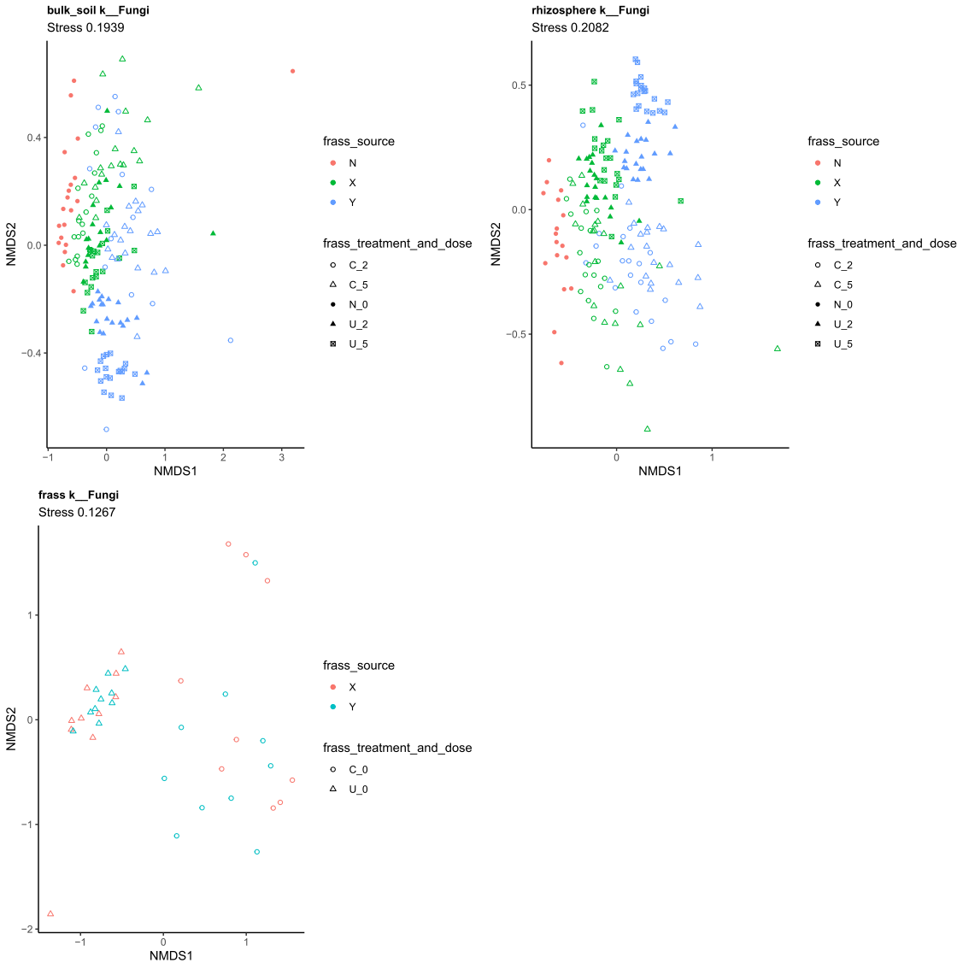

**Fig. 2** Non-metric multidimensional scaling (NMDS) plot of the beta diversity of **fungal** communities in the rhizosphere, bulk soil and frass data based on bray-Curtis' distances. The stress values are used as a measure of how well the plot represents the dissimilarity or distance between the data points. The stress value ranges from 0 to 1, where lower values indicate a better fit or representation of the original dissimilarity matrix. A stress value close to 0 suggests a highly accurate representation of the data, meaning that the distances between points in the NMDS plot closely match the original dissimilarities. On the other hand, a stress value closer to 1 indicates a poorer fit, suggesting that the NMDS plot does not accurately reflect the dissimilarity structure of the data.

NMDS_BacFun_BulkRhizo: Beta diversity of microbial communities.

The analysis revealed significant three-way interactions, suggesting that all factors examined (frass treatment, frass source, and dose) play important roles in shaping the microbial community structure. Furthermore, these factors were found to interact with each other, indicating complex relationships among them. Among the various two-way interactions investigated, the frass treatment and frass source interaction stood out as the most influential, exhibiting significant effects with the highest R2 values across all sub-communities. This interaction implies that the composting process induces distinct shifts in microbial communities depending on the specific frass sources employed.

Notably, the main effect of the Frass source was found to be the most significant (highest R2 value) in determining the composition of bulk soil bacteria. On the other hand, for the remaining sub-communities, the frass treatment emerged as the most important factor for distinguishing microbial communities (refer to Fig. 3).

Regarding the impact of dose on composted frass, it was observed that frass source Y exhibited a more pronounced effect compared to frass source X. This disparity was particularly evident in the rhizosphere samples. In the case of bulk soil samples, composting exerted a stronger influence on the fungal population of frass source Y, while significantly affecting the bacterial community associated with frass source X (refer to Fig. 3).

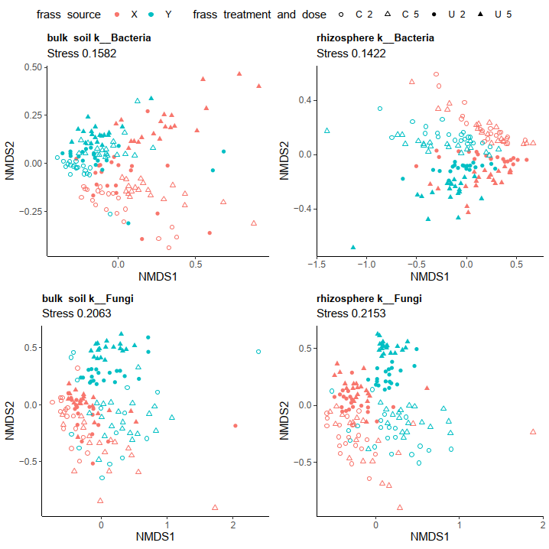

**Fig. 3** Non-metric multidimensional scaling (NMDS) plot of the beta diversity of **bacterial** and **fungal** communities in the rhizosphere and bulk soil samples based on bray-Curtis' distances. The stress values are used as a measure of how well the plot represents the dissimilarity or distance between the data points. The stress value ranges from 0 to 1, where lower values indicate a better fit or representation of the original dissimilarity matrix. A stress value close to 0 suggests a highly accurate representation of the data, meaning that the distances between points in the NMDS plot closely match the original dissimilarities. On the other hand, a stress value closer to 1 indicates a poorer fit, suggesting that the NMDS plot does not accurately reflect the dissimilarity structure of the data.

**Table 1.** Permutational multivariate analysis of variance (PERMANOVA) results for frass treatment, source, dose, and interactions

|  |  |  |  |  |  |  |  |
| --- | --- | --- | --- | --- | --- | --- | --- |
| **Microorganism** | **Plant compartment** | **Factors/Variables Investigated** | **PERMANOVA** | | | | |
| **df** | **R2 value** | **F value** | **P value** | **Sig. level** |
| Bacteria | Bulk soil | Frass treatment | 1 | 0.123 | 35.155 | 0.001 | *** |
|  |  | Frass source | 1 | 0.185 | 52.850 | 0.001 | *** |
|  |  | Frass dose | 1 | 0.068 | 19.526 | 0.001 | *** |
|  |  | Frass treatment: Frass source | 1 | 0.059 | 16.817 | 0.001 | *** |
|  |  | Frass treatment: Frass dose | 1 | 0.012 | 3.539 | 0.004 | ** |
|  |  | Frass source: Frass dose | 1 | 0.017 | 4.846 | 0.001 | *** |
|  |  | Frass treatment: Frass source: Frass dose | 1 | 0.012 | 3.323 | 0.002 | ** |
|  | Rhizosphere | Frass treatment | 1 | 0.131 | 32.862 | 0.001 | *** |
|  |  | Frass source | 1 | 0.112 | 27.940 | 0.001 | *** |
|  |  | Frass dose | 1 | 0.056 | 14.000 | 0.001 | *** |
|  |  | Frass treatment: Frass source | 1 | 0.067 | 16.693 | 0.001 | *** |
|  |  | Frass treatment: Frass dose | 1 | 0.012 | 3.111 | 0.005 | ** |
|  |  | Frass source: Frass dose | 1 | 0.013 | 3.269 | 0.002 | ** |
|  |  | Frass treatment: Frass source: Frass dose | 1 | 0.006 | 1.602 | 0.086 | ns |
| Fungi | Bulk soil | Frass treatment | 1 | 0.140 | 27.090 | 0.001 | *** |
|  |  | Frass source | 1 | 0.065 | 12.521 | 0.001 | *** |
|  |  | Frass dose | 1 | 0.013 | 2.588 | 0.029 | * |
|  |  | Frass treatment: Frass source | 1 | 0.026 | 5.030 | 0.001 | *** |
|  |  | Frass treatment: Frass dose | 1 | 0.013 | 2.480 | 0.020 | * |
|  |  | Frass source: Frass dose | 1 | 0.015 | 2.823 | 0.018 | * |
|  |  | Frass treatment: Frass source: Frass dose | 1 | 0.714 | 2.803 | 0.017 | * |
|  | Rhizosphere | Frass treatment | 1 | 0.142 | 33.483 | 0.001 | *** |
|  |  | Frass source | 1 | 0.104 | 24.433 | 0.001 | *** |
|  |  | Frass dose | 1 | 0.025 | 5.831 | 0.001 | *** |
|  |  | Frass treatment: Frass source | 1 | 0.044 | 10.441 | 0.001 | *** |
|  |  | Frass treatment: Frass dose | 1 | 0.018 | 4.266 | 0.002 | ** |
|  |  | Frass source: Frass dose | 1 | 0.018 | 4.210 | 0.001 | *** |
|  |  | Frass treatment: Frass source: Frass dose | 1 | 0.014 | 3.363 | 0.005 | ** |

R2 value indicates the amount of variation that can be attributed to each specific factor or interaction being investigated (e.g., Frass treatment, Frass source, Frass dose, etc.). It ranges from 0 to 1, where 0 means that the factors have no effect on the variation, and 1 means that the factors explain all the observed variation. A higher R2 value indicates a stronger influence of the factors on the multivariate data. Significance codes: 0.001 ‘**’ 0.01 ‘*’ ≥ 0.05 ‘ns’; ns = not significant.

[To-do: add stats of permanovas into this fitures (R2, P; if it fits, add F values; include interactions]

[Pedro to-do: pariwse post-hoc tests for memanova]

**heattree_Bac_pannel heattree_Bac_pannel:**

These are the taxonomies of the ASVs classified as differentially abudnant in pairwise comparisons by the deseq2 algorithm. Composting clearly increased the abundance of firmicutes bacteria, in both bulk soil and rhizosphere.The paenibacillaceae group however was more abundant in the Uncomposted frass then on the composted frass. This indicates that composting is shifgin parts of the firmicutes communities from Paenibacillus to Bacillus. In addition, uncomposted frass has more and more diverse proteobacteria groups. It also shows more and more diverse bacteriodota, which includes Chitinophagaceae.

For the source_treatment effect, Source X had more firmicutes, Verrucomicrobiae and bacteriodota than source Y in both bulk soil and rhizosphere samples. The higher abundance of actinobacteria on source Y at bulk soils is not visible on the rhizosphere (the plant is equalizing these communities across frass source in the rhizosphere)

For frass dose, whch is affected by layers of interactions, we see higher populations of several common taxa at dose 5g, specially on the bulk soil when comapred to rhizopshere. Notably, genus Mucilaginibacter is more abundant on dose2 than dose 5

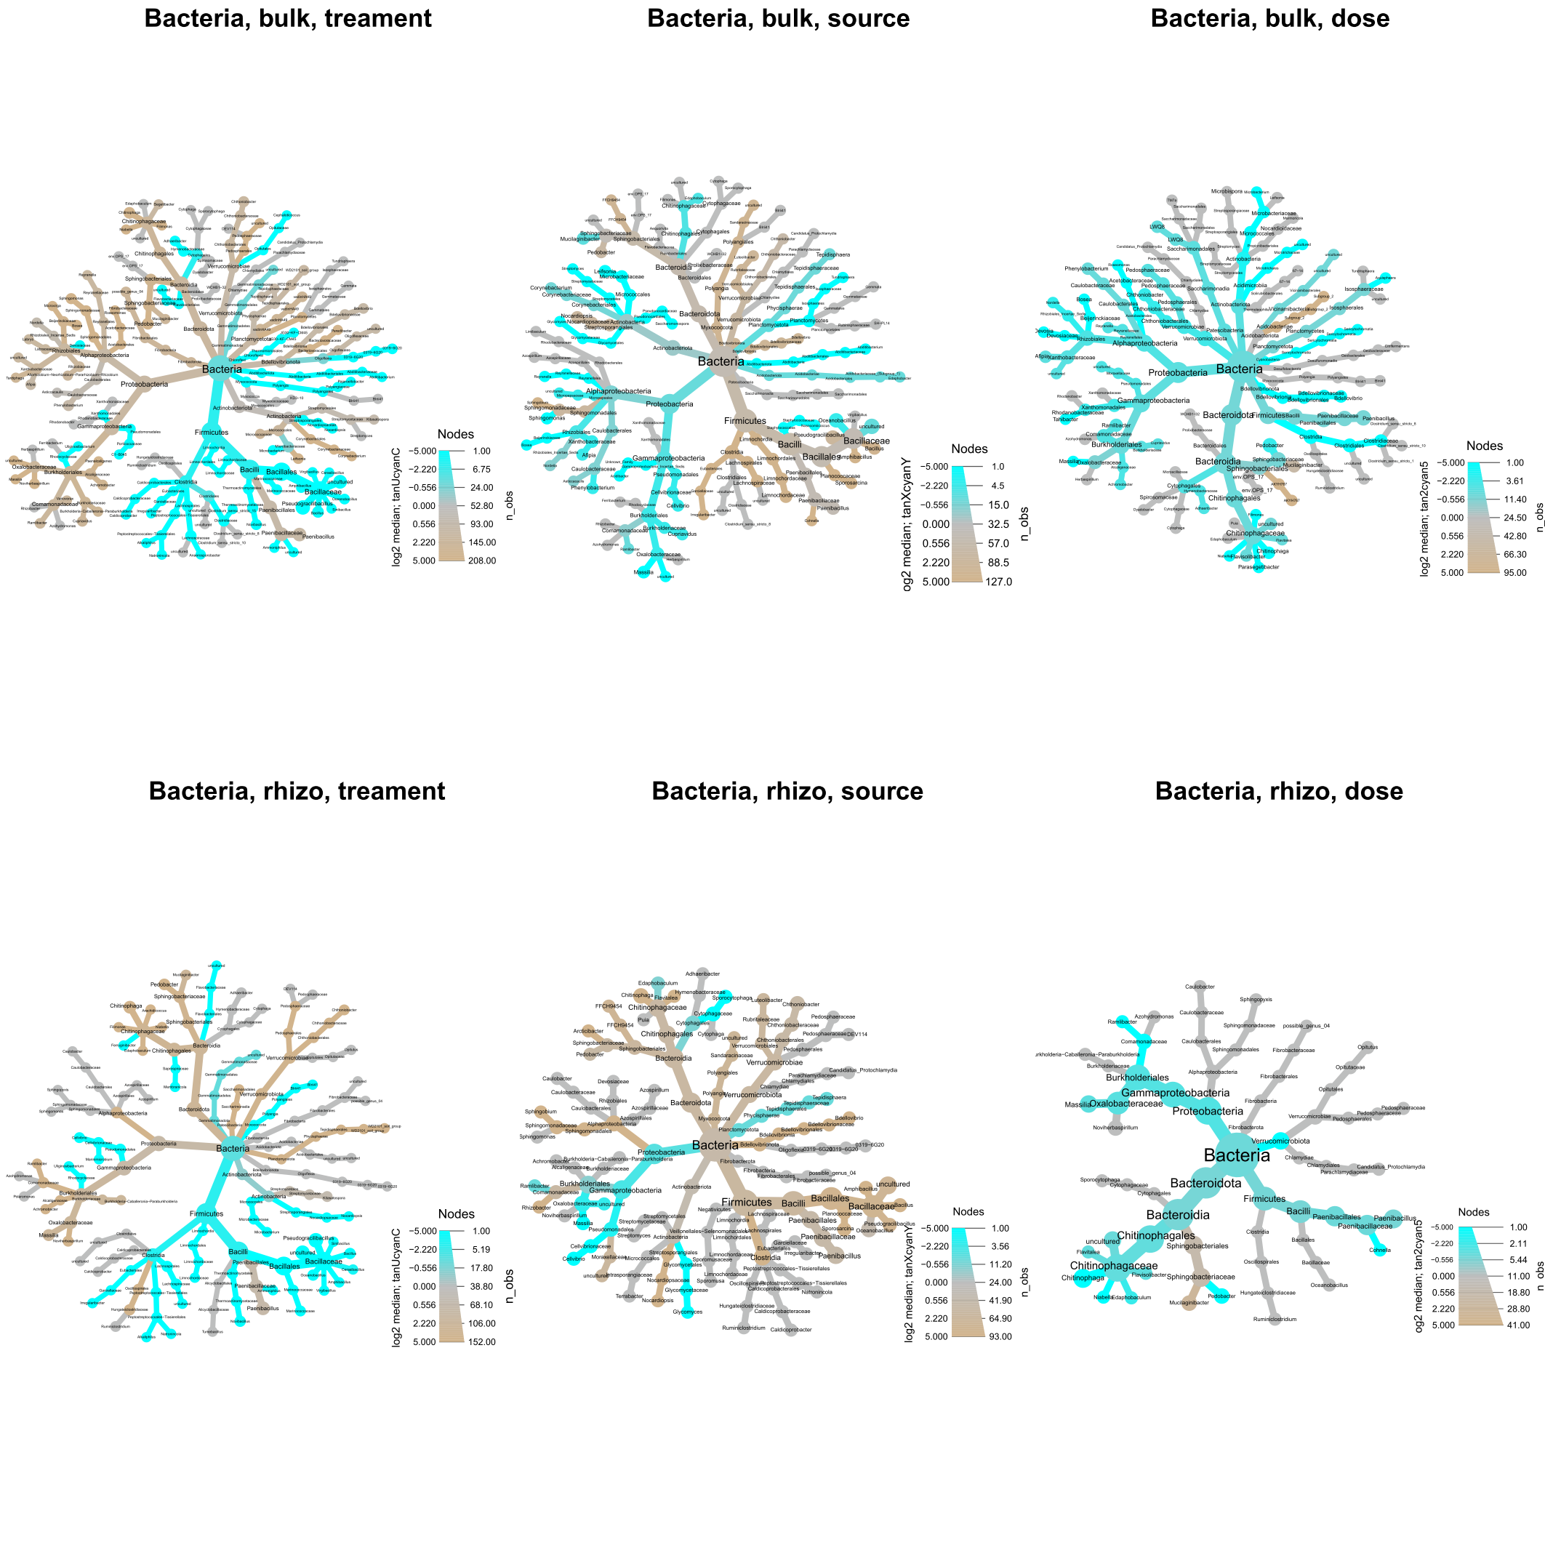

**Fig. 4** Heat trees illustrating the taxonomic abundances of **bacteria** in the **bulk soil** and **rhizosphere** communities treated with **uncomposted** and **composted frass** from two different black soldier fly (BSF) rearing **sources (X and Y)** at two varying **doses**. The size and colour of nodes and edges correspond to the relative abundance of microorganisms within each community.

heattree_Fun_pannel: **Fungi**

The results of the study indicate the influence of composting, frass source, and frass dose on the abundance of fungal taxa in the bulk soil and rhizosphere.

1. **Impact of Composting:** Composting was found to increase the abundance of Ascomycota in both the bulk soil and rhizosphere samples. This suggests that the composting process promotes the growth and colonization of Ascomycota fungi in these environments.
2. **Influence of Frass Source:** Frass source Y exhibited a higher presence of Ascomycota compared to frass source X in both bulk soils and the rhizosphere. This indicates that the fungal community composition varies depending on the source of the frass, with frass source Y favouring the growth of Ascomycota.
3. **Rhizosphere-Specific Effects:** Uncomposted frass showed a higher abundance of Mortierella in the rhizosphere compared to composted frass. Moreover, frass source X displayed a higher abundance of Mortierellomycota specifically in the rhizosphere. These findings suggest that the rhizosphere environment influences the composition and distribution of fungal taxa associated with frass.
4. **Frass Dose Effect:** Comparing different frass doses, it was observed that dose 5 resulted in a higher abundance of Ascomycota compared to dose 2. This suggests that a higher frass dose promotes the proliferation of Ascomycota fungi in both bulk soils and the rhizosphere.

In conclusion, composting enhances the presence of Ascomycota in the bulk soil and rhizosphere, while uncomposted frass and frass source Y favour the growth of Ascomycota. Frass source X and higher frass doses are associated with an increased abundance of Mortierella and Ascomycota, respectively. These results provide insights into the fungal community dynamics influenced by composting, frass source, and frass dose, contributing to a better understanding of the factors shaping microbial communities in agricultural systems.

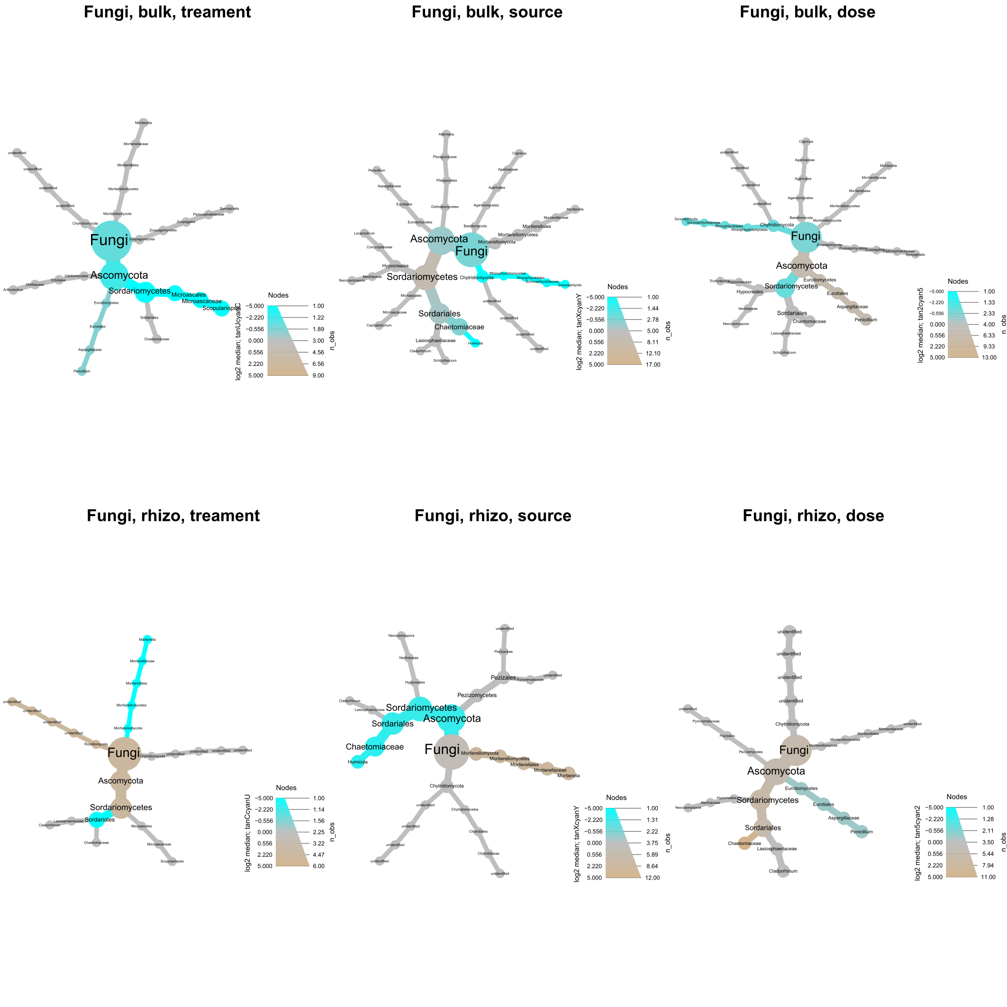

**Fig. 5** Heat trees illustrating the taxonomic abundances of **fungi** in the **bulk soil** and **rhizosphere** communities treated with **uncomposted** and **composted frass** from two different black soldier fly (BSF) rearing **sources (X and Y)** at two varying **doses**. The size and colour of nodes and edges correspond to the relative abundance of microorganisms within each community.

heattree_Bac_source_on_CompostedUncomposted:

The taxonomic analysis of ASVs (Amplicon Sequence Variants) classified as differentially abundant in pairwise comparisons using the DESeq2 algorithm revealed interesting findings when comparing frass sources X and Y in both composted and uncomposted samples, specifically focusing on bulk soils and the rhizosphere (Fig. 6).

Bulk Soils:

* Alphaproteobacteria and Actinobacteria showed slightly higher abundance in uncomposted frass from source X compared to source Y. However, composting clearly increased their abundance in source Y.
* The bacillaceae clade was generally more abundant in source X than in source Y for uncomposted frass, except for the presence of paenibacillus, which was more prevalent in source Y.
* When comparing composted frass, source X still had higher abundances of Firmicutes and Bacilli, while source Y exhibited more Bacialles and Bacillaceae. Within the Bacillaceae family of composted frass, some genera were more abundant in source Y, while others were more abundant in source X (Fig. 6).

Rhizosphere:

* Differences between sources X and Y were observed in sub-groups of Proteobacteria in the rhizosphere, and these differences were not significantly affected by composting.
* Actinobacteriota, Verrucomicrobiota, and Bacteroidota were generally more abundant in source X compared to source Y in the rhizosphere, and this pattern remained consistent with composting.
* Source X exhibited a higher overall abundance and diversity of Firmicutes in the rhizosphere, but composting also resulted in Clostridia becoming a major distinguishing factor between sources X and Y within this branch of the taxonomy tree, with a higher abundance of Clostridia in source X (Fig. 6).

In summary, the analysis of composted and uncomposted samples from sources X and Y in both bulk soils and the rhizosphere revealed distinct taxonomic differences. Composting had a clear impact on the abundance of certain bacterial groups, particularly in bulk soils, where it increased the abundance of Alphaproteobacteria and Actinobacteria in source Y. Differences between sources X and Y in the rhizosphere were observed primarily in sub-groups of Proteobacteria, and these differences were not significantly altered by composting. Source X consistently showed higher abundance and diversity of Firmicutes, while composting introduced differences in Clostridia abundance between sources X and Y (Fig. 6).

to-do: evaluate these interaction effects on the fungi plots, heattree_Fun_source_on_CompostedUncomposted.

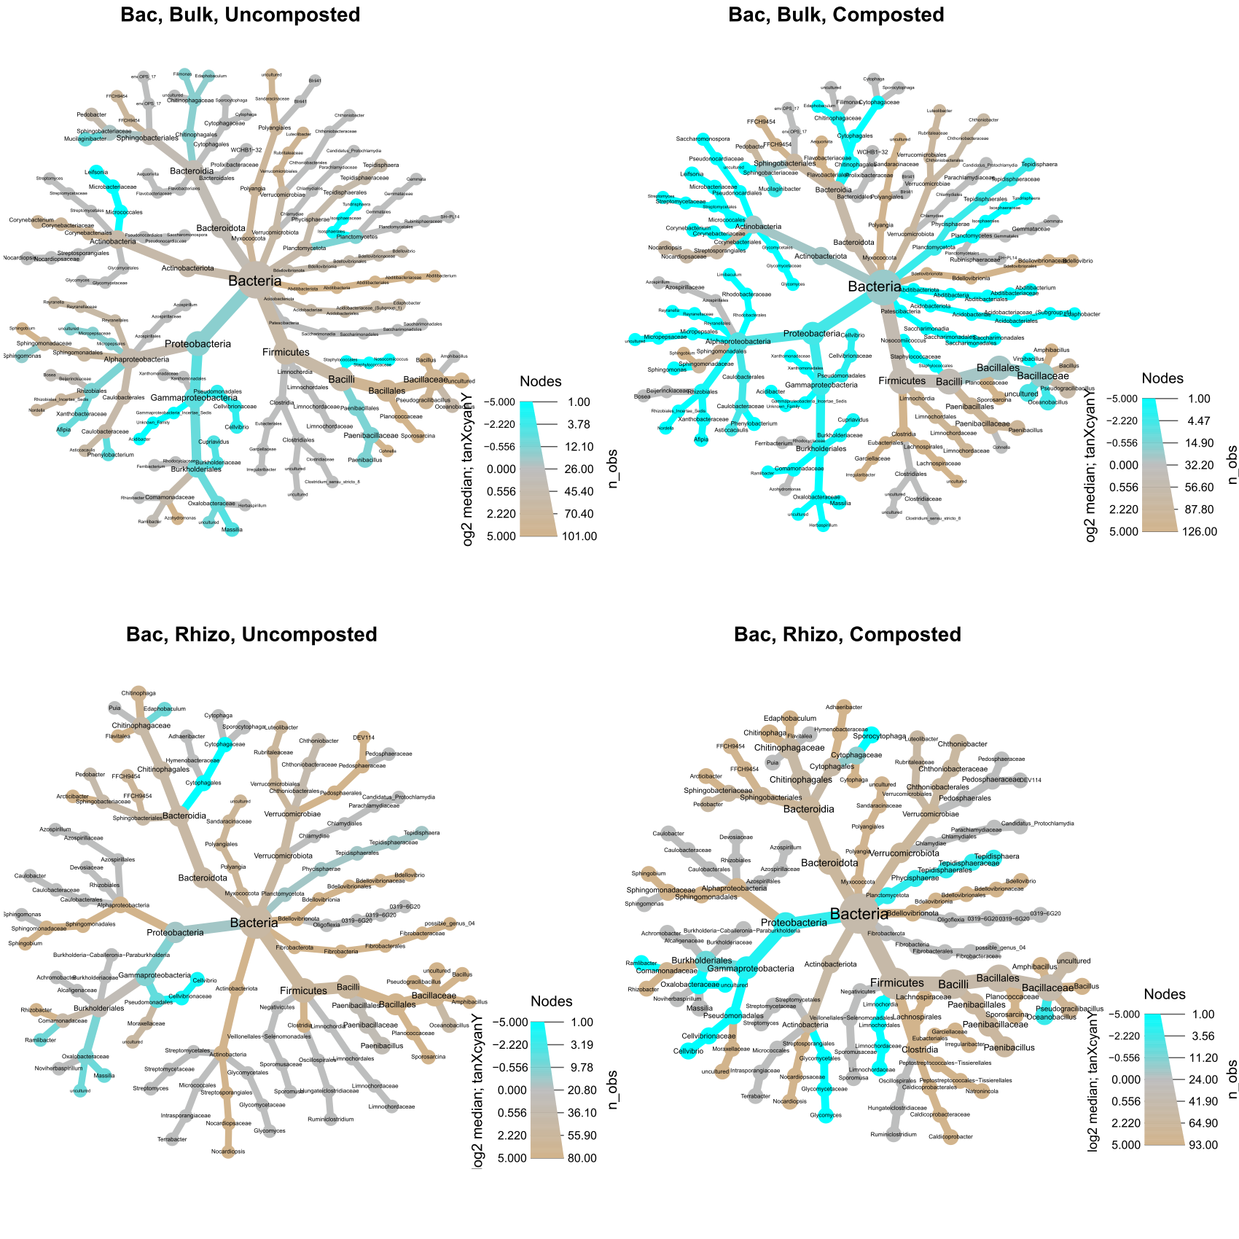

**Fig. 6** Heat trees illustrating the taxonomic abundances of **bacteria** in the **bulk soil** and **rhizosphere** communities treated with **uncomposted** and **composted frass** from two different black soldier fly (BSF) rearing **sources (X and Y)**. The size and colour of nodes and edges correspond to the relative abundance of microorganisms within each community.

heattree_BacFun_Dose_025: Bacteria

In the comparisons of different frass doses (0, 2, and 5), focusing on the ASVs that showed differential abundance in pairwise comparisons of 0 vs 2 and 0 vs 5, several notable findings emerged.

1. Increased Abundance of Alpha and Gamma Proteobacteria: The addition of frass to the soil led to a significant increase in the abundance of both alpha and gamma proteobacteria. This suggests that frass positively influences the presence and growth of these bacterial groups in the soil environment.
2. Expansion of Chloroflexi and Firmicutes Groups: The inclusion of frass in the soil also resulted in a notable increase in the abundance of Chloroflexi and various Firmicutes groups. This implies that frass supplementation promotes the proliferation of these bacterial taxa in the soil ecosystem.
3. Significant Rise in Chitinophagaceae: The addition of frass to the soil caused a pronounced and significant increase in the abundance of Chitinophagaceae. This indicates that frass plays a crucial role in promoting the growth and prevalence of this specific bacterial family.
4. Differential Presence of Gammaproteobacteria and Nitrospira in Rhizosphere Samples: In rhizosphere samples from the 0-frass group, a few groups of gammaproteobacteria, including Polycyclovorans, Arenimonas, and Nitrosomonadaceae, were found to be more abundant. Additionally, the presence of Nitrospira, which is associated with algae, was also higher in these samples. These findings suggest that the absence of frass in the rhizosphere may influence the composition and abundance of these bacterial groups.

In summary, the addition of frass to the soil led to a significant increase in the abundance of alpha and gamma proteobacteria, as well as Chloroflexi and various firmicutes groups. Chitinophagaceae showed a marked increase in response to frass supplementation. Furthermore, certain gammaproteobacteria and Nitrospira exhibited differential presence in rhizosphere samples without frass. These findings shed light on the impact of frass on microbial community composition and highlight the potential role of frass in shaping specific bacterial groups in the soil and rhizosphere environments. (See Figure 7 for a visual representation of these results.)

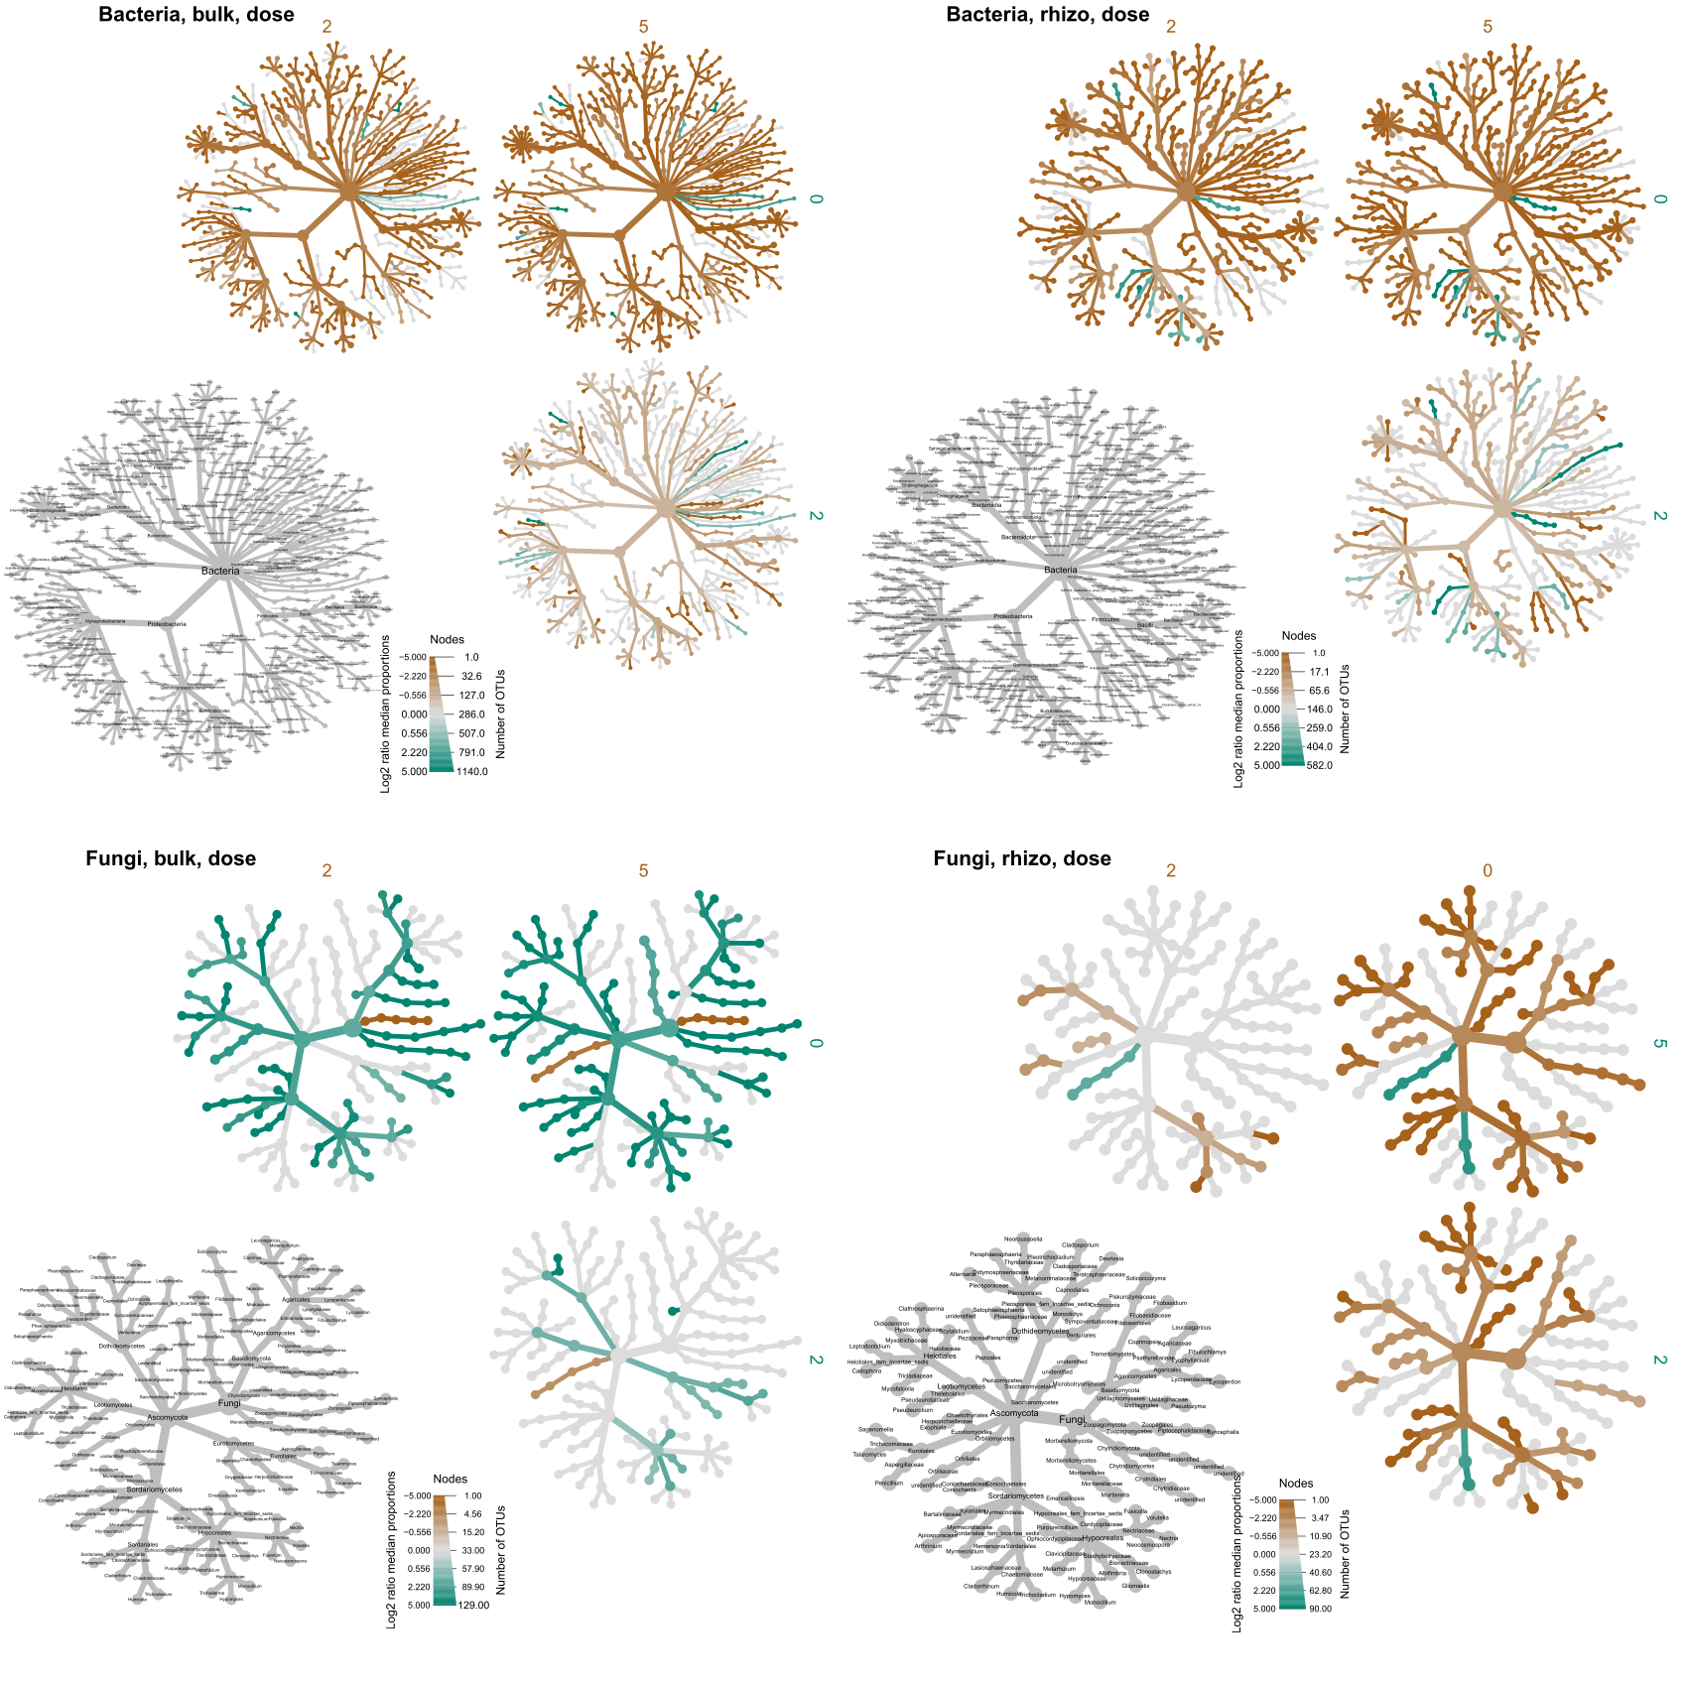

**Fig. 7** Heat trees illustrating the taxonomic abundances of **bacteria** in the **bulk soil** and **rhizosphere** communities when unamended (0) or when amended with black soldier fly **frass** at two **doses (2 and 5 g/kg soil)**. The colour of nodes corresponds to the relative abundance of microorganisms within each community.

heattree_BacFun_Dose_025: Fungi

Comparing the frass doses of 0, 2, and 5 grams, we focused on the ASVs (Amplicon Sequence Variants) that exhibited differential abundance in the pairwise comparisons of 0 vs 2 and 0 vs 5. In contrast to the bacterial communities, the frass dose did not appear to be the primary factor influencing fungal communities (Fig. 8). Instead, the frass source emerged as the key differentiating factor for fungal communities in both bulk soil and rhizosphere samples, as evident from the beta diversity plots (Fig. 2).



**Fig. 8** Heat trees illustrating the taxonomic abundances of **fungi** in the **bulk soil** and **rhizosphere** communities in unamended (0) or when amended with black soldier fly **frass** at two **doses (2 and 5 g/kg soil)**. The colour of nodes corresponds to the relative abundance of microorganisms within each community.

heattree_BacFun_source_NXY: Bacteria

The frass source did not appear to be the primary factor influencing **bacterial communities** (Fig. 9). Instead, the frass dose emerged as the key differentiating factor for bacterial communities in both bulk soil and rhizosphere samples, as evident from the beta diversity plots (Fig. 1).

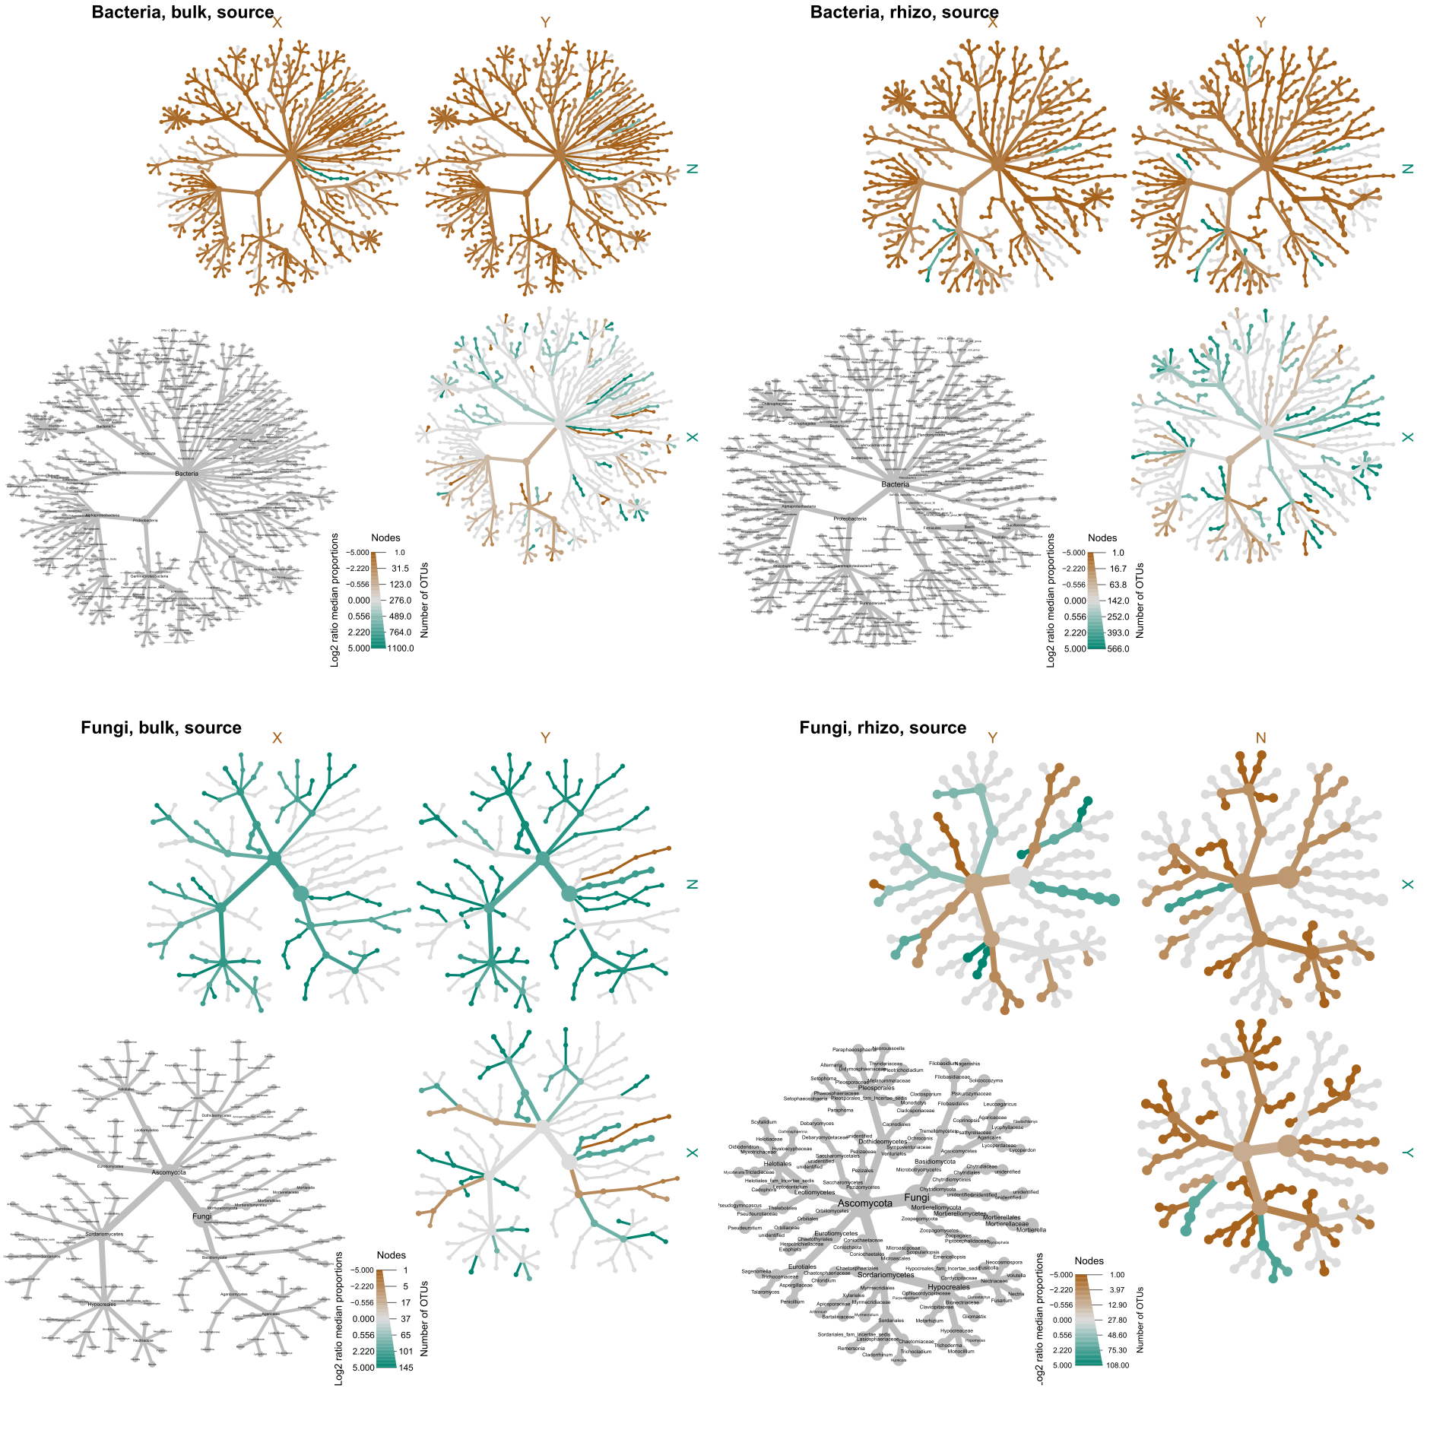

**Fig. 9** Heat trees illustrating the taxonomic abundances of **bacteria** in the **bulk soil** and **rhizosphere** communities in unamended (N) or when amended with black soldier fly **frass** from two different **sources (X and Y)**. The colour of nodes corresponds to the relative abundance of microorganisms within each community.

heattree_BacFun_source_NXY: Fungi

The addition of frass to bulk soil led to significant suppression of most fungal groups when comparing the treatment with frass from sources X and Y relative to the NoFrass control (N). Similar results were observed in the rhizosphere, with the exception of differences in specific fungal groups. In the rhizosphere, the presence of Orbiliaceae was more pronounced in source X, while Penicillium and Chaetomiaceae ASVs were more abundant in source Y (Fig. 10).



**Fig. 10** Heat trees illustrating the taxonomic abundances of **fungi** in the **bulk soil** and **rhizosphere** communities in unamended (N) or when amended with black soldier fly **frass** from two different **sources (X and Y)**. The colour of nodes corresponds to the relative abundance of microorganisms within each community.alpha_div_3_sample_types: Bulk soil, Frass and Rhizosphere

Shannon's diversity index was used to assess the diversity of microbial communities in bulk soil, rhizosphere, and frass samples.

1. Bacterial Diversity: a. Frass Impact on Bulk Soil and Rhizosphere: The addition of frass to bulk soil and rhizosphere samples did not have a significant impact on bacterial diversity, although there was a slight reduction observed (pending statistical testing). Further analysis is required to confirm this trend. b. Frass Diversity Comparison: Frass-only samples from source Y exhibited lower diversity compared to frass from source X. However, upon composting, this difference in diversity between the two sources disappeared, indicating that the composting process increased diversity for both frass sources.
2. Fungal Diversity: a. Frass Impact on Bulk Soil and Rhizosphere: Frass was found to significantly decrease fungal diversity in both bulk soil and rhizosphere samples. The addition of frass resulted in a reduction in the richness and abundance of fungal species in these environments. b. Challenges with ITS Amplicon Sequencing: Uncomposted frass samples presented challenges with ITS amplicon sequencing, potentially due to low fungal biomass in the source samples. As a result, it was difficult to obtain accurate data on fungal diversity from uncomposted frass samples. c. Composting and Fungal Diversity: Composting facilitated alpha diversity comparisons, revealing low diversity levels that were similar between frass sources X and Y after the composting process.

In conclusion, the addition of frass to bulk soil and rhizosphere samples had minimal effects on bacterial diversity, with a slight reduction observed (pending statistical testing). Frass from source Y initially exhibited lower diversity compared to frass from source X, but this difference disappeared after composting, indicating an increase in diversity for both sources. However, frass was found to significantly decrease fungal diversity in both bulk soil and rhizosphere samples. Uncomposted frass samples presented challenges with ITS amplicon sequencing, potentially due to low fungal biomass. Overall, composting resulted in low fungal diversity levels that were similar between frass sources X and Y (**Fig. 11)**.

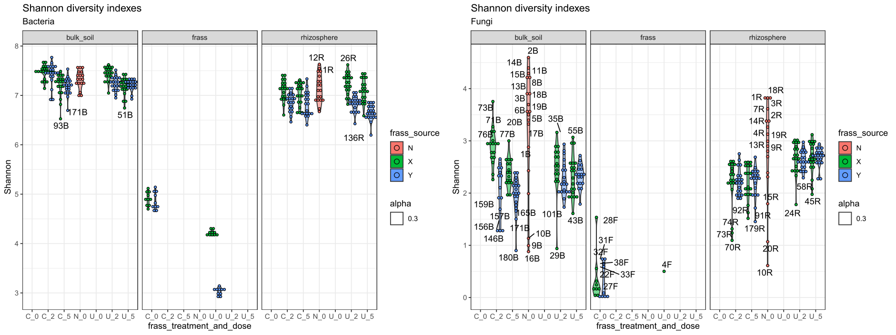

**Fig. 11.**

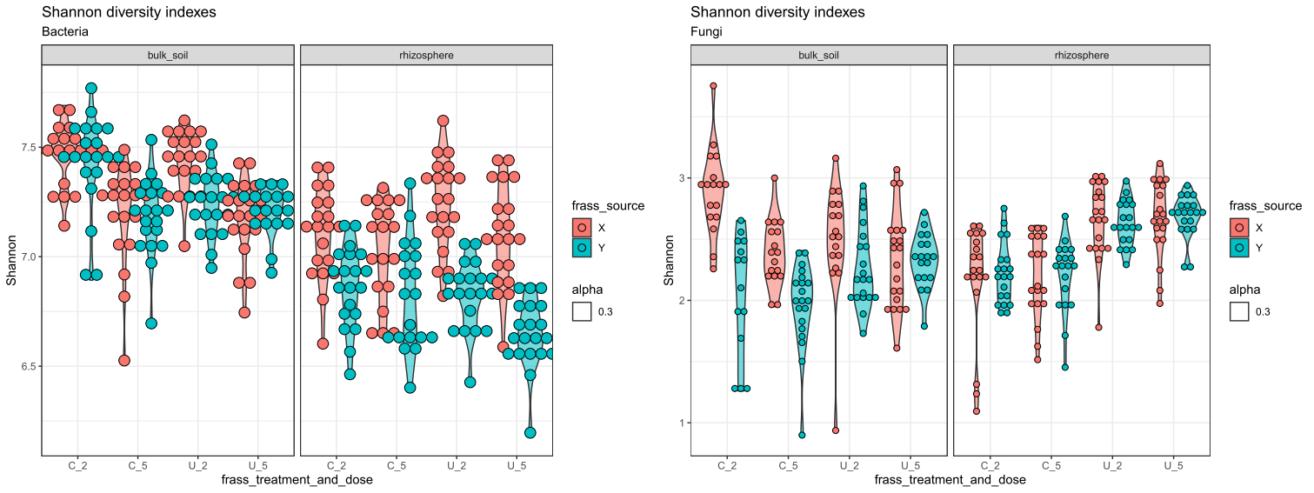

alpha_div_BacFun_BulkRhizo: shannon diversity, which should account for the apha diversity tests thatw ere performed. Bac$bulk_soil: Frass dose has a major influence, which depends on frass source and treatment. higher dose seems to reduce diversity, specially in composted frass. this difference is more evident in frass X than on frass Y. $Bac$rhizosphere: Frass source drives alpha diversity (X more diverse than Y), with interactions with frass treatment. composting decreases diversity of X_2, but increases diversity of Y_5. diversity of dose 2 was higher than that of dose 5. $Fun$bulk_soil: frass source drives alpha diversity, with strong interaction with frass treatment. X is more diverse than Y, but composting reduces the diversity of Y while increasing diversity of X. high dose diminishes the diversity of composted frass, but not of uncomposted frass. $Fun$rhizosphere: onyl frass treatment affects alpha diversity. compoting frass reduces fungal diversity. [TO-DO: incorporate pairwise comparisons] overall, there are interactions and dependencies across the board. higher dose has a tendency to reduce diversity. composting accentuates the differences between the frass sources in bulk soil, but reduces such difference in teh rhizosphere